Chapter 19, Problem 70.

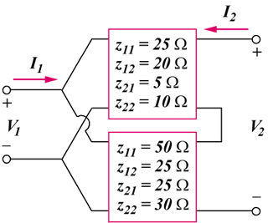
For the parallel-series connection of the two two-ports in Fig.19.117, find the g parameters.

Figure 19.117
For Prob. 19.70.

